

Progress Report No.4
Unitas System
Document Version 1.0
Prepared by Limbo Software Development

Rodrigo Alejandro Hurtado Cortés - A01713854

Alexis Yaocalli Berthou Haas - A01713458

Ana Camila Cuevas González - A01412609

Alejandro Contreras Magallanes - A01662743

March 26th, 2026
Table of Contents

1. Functional Requirements Analysis 1
2. Software Architecture 2
2.3. Technology stack 3
2.3.1. Backend 3
2.3.2. Frontend 3
2.3.3. Development tools 3
2.4. Project Structure 3
2.5. Interfaces Between the Software Application and External Data Sources 4
2.6. Architectural Support for Non-Functional Requirements 4
3. Functional requirements Design & Implementation 4
3.1. Functional Requirements Design 4
3.2. Functional Requirements Implementation 5
4. Test Design & Execution 6
5. Usability 7
6. Reports 12
7. Production Environment Identification 14
8. Updated Work Plan 17
9. Acquired Learning 19

Table of Figures

Figure 1.1 & 1.2 Pie graph of Functional Requirements Description & Activity Diagrams. 1
Figure 2. General Software with MVC Architecture 2
Figure 3. Project Structure Example 3
Figure 4. Pie Graph Sequence Diagrams Design 5
Figure 5. Pie Graph Development 6
Figure 6. Pie Chart Test Cases Design 7

For the current advancement report and a clear advancement strategy a progress matrix has been created; from it, all graphs and percentages are presented in the current file.

For evaluation, it is necessary to mention some standards from it:
- Each functional requirement in the matrix has a weight based on its valoration over: priority, implementation difficulty, project failing risk & feature stability.
- Each stage of each requisite is cataloged based on the following labels:
  - Non-started 0%
  - In progress 25%
  - Completed 50%
  - Validated 75% (Checked by a developer, yet not approved)
  - Approved 100%
  - Context Question 50% (The functional requirement requires information from client)

The previously mentioned Progress Matrix can be accessed through the following link:

Priorización de Requisitos - Unitas System

Functional Requirements Analysis
The functional requirement analysis is composed of overall two sections: functional requirement description and activity diagram.

All descriptions and activity diagrams are presented in the document Functional Requirements Decomposition which is available in the following file link:

Functional Requirements Decomposition - Unitas System

From it we obtain the following graphs:

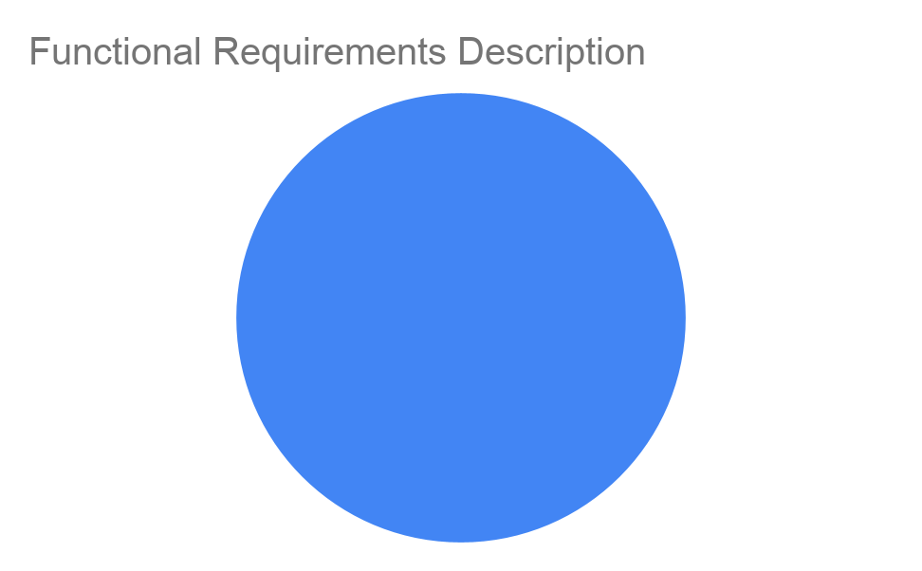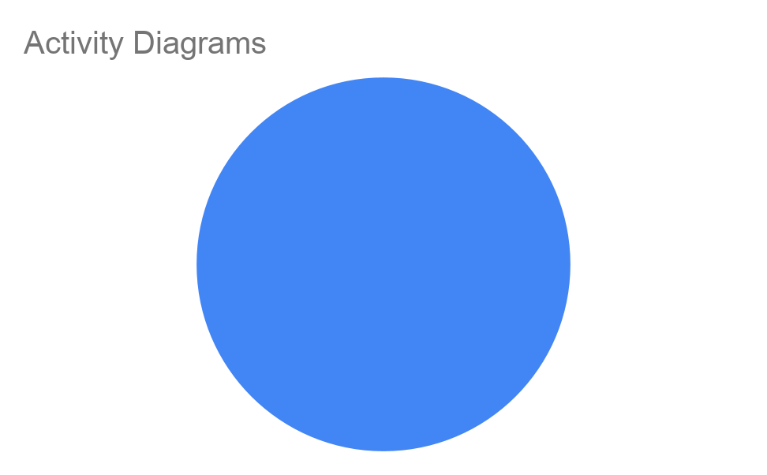

Figure 1.1 & 1.2 Pie graph of Functional Requirements Description & Activity Diagrams.

As it can be appreciated most of the functional requirements have been approved, yet not all of them.
This ends in the following percentages:

Description | 100.00%
Activity Diagram | 100.00%
Total Analysis | 100.00%

Software Architecture
  - General structure and architectural style
The application follows a Server-Side Rendered (SSR) web architecture using a layered Model-View-Controller (MVC) style. Incoming HTTP requests are handled by route definitions, controllers orchestrate use cases, models encapsulate data access logic and execute database queries, and EJS views are responsible for rendering HTML responses to the client.
Additionally, the codebase adopts a modular, feature-oriented decomposition, where business functionality is organized into cohesive modules such as “auth”, “employee”, and “team”.
At runtime, app.js serves as the composition root. It configures static assets, session management, CSRF protection, navigation middleware, and registers routes for all modules. Requests typically flow through Express middleware, into a feature-specific route, then into a controller, followed by one or more models, and finally result in an EJS page or partial rendered within a shared application layout.
Client-side JavaScript is intentionally kept minimal and is used only for progressive enhancement of specific interface behaviors such as navigation menus, search interactions, or modal controls.

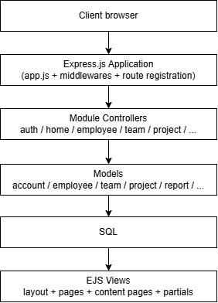

Figure 2. General Software with MVC Architecture

  - Architecture Components
- Routes: Define endpoints and map to controllers (/users, /projects).
- Middleware: Process requests before reaching controllers (auth, validation, logging).
- Modules: Business logic and controllers grouped by feature (user management, project handling).
- Models: Database interactions and data schemas.
- Views: EJS templates that render dynamic HTML.
- Static Assets: CSS, JavaScript, images served directly by Express.

Technology stack

Backend
- Runtime: Node.js v18+
- Framework: Express.js v5.2.1
- Template Engine: EJS v4.0.1
- Body Parser: Express built-in

Frontend
- CSS Framework: Tailwind CSS v4.2.1

Development tools
- Package Manager: npm
- CSS CLI: Tailwind CLI v4.2.1
- Hot Reload: Node.js --watch flag
- Version Control: Git

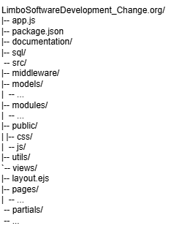
Project Structure

Figure 3. Project Structure Example

Interfaces Between the Software Application and External Data Sources
The main interface between the application and external data is the MySQL relational database, which is accessed through the mysql2 driver and a model layer that encapsulates SQL queries. Through this interface, the system stores and retrieves its main entities, including accounts, employees, teams, projects, collaborations, activities, goals, achievements, reports, and access control data. This separation ensures that business logic does not interact directly with the database, but instead relies on specialized models that serve as the persistence boundary of the system.

Another relevant interface is the one established with the web browser through HTTP. The application receives requests from forms and navigation actions, and returns HTML pages rendered on the server using EJS. In some cases, it also exchanges data in JSON format to support asynchronous behaviors such as dynamic search or partial interface updates. In addition, the system uses session cookies as a state interface between client and server, allowing authentication and user context to persist across requests.

Architectural Support for Non-Functional Requirements
The architecture supports performance through a simple layered flow between routes, controllers, models, and the database, which helps keep page loads and data operations efficient. Its modular structure also allows heavier processes, such as report generation and AI parsing, to be optimized separately.

It supports security and safety through authentication middleware, session handling, password hashing, RBAC-oriented role/privilege data, and the use of environment variables for secrets. Validation logic in controllers and models also provides a place to enforce rules such as one Daily Entry per employee per day.

It supports usability, compatibility, and accessibility through server-side rendered EJS views, reusable partials, and responsive styling with Tailwind, DaisyUI, and Flowbite. Finally, the use of MySQL ensures data persistence across restarts, while the modular project structure and documented setup improve maintainability, scalability, and reproducibility.

Functional requirements Design & Implementation

Functional Requirements Design
Functional Requirements Design makes reference to the creation and validation of sequence diagrams based on standards learned and adapted to the Unitas System Architecture presented above.

All available sequence diagrams are presented in the document Functional Requirements Decomposition which is available in the following file link:

Functional Requirements Decomposition - Unitas System

And in the main branch of the Unitas System repository:

https://github.com/Berthou05/LimboSoftwareDevelopment_Change.org

Its completion can be observed in the following graph:

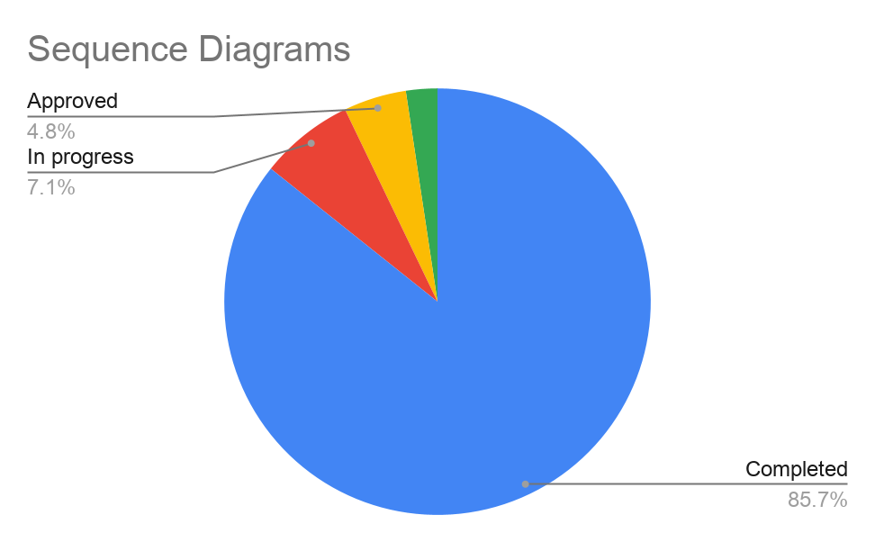

Figure 4. Pie Graph Sequence Diagrams Design

As appreciated the completion is almost over; however there has not been validation due to time pressures and continuous corrections over the analysis section. Giving a result of:

Sequence Diagram | 53.47%

Functional Requirements Implementation
Making a clear correlation with the previous sections, the implementation of the functional requirements has not achieved the required 30% and overall it's potentially lower than the showed result as the use of AI agent CODEX despite bringing an acceleration to the presented product has reduced the engineering process mainly on backend resulting in an overall counter measure that must be corrected in order to implement the planned way the features presented.

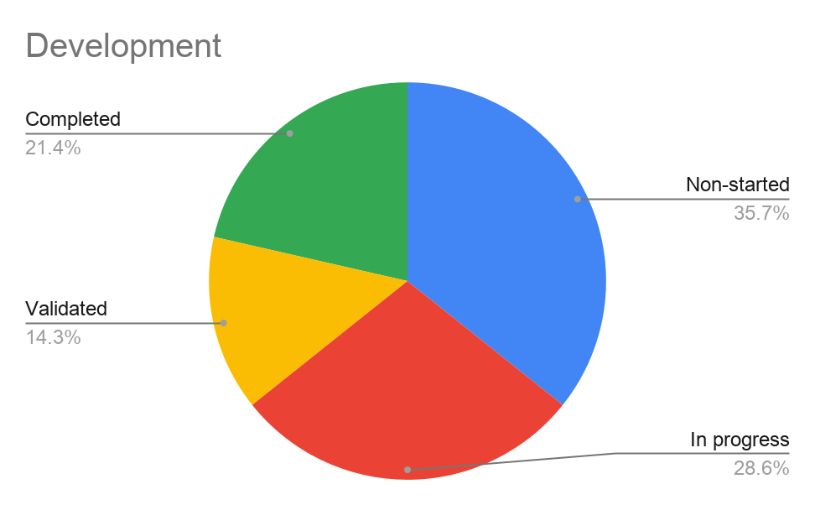

Figure 5. Pie Graph Development

Functionalities explanation:
- Completed show functional requirements with visualization in front-end, logic working in back-end and data fetch from database. Real percentage lower as corrections are required.
- In-progress show functional requirements without any of the previously presented three components of Completed. Real percentage lower as corrections are required.

Development | 30.26%

Test Design & Execution
All available Test Cases are presented in the document which is available in the following file link:

Functional Requirements Decomposition - Unitas System

Similarly to development in the previous section, Test Cases Design has been minimal as no Analysis has been completed at all, opening the following results:

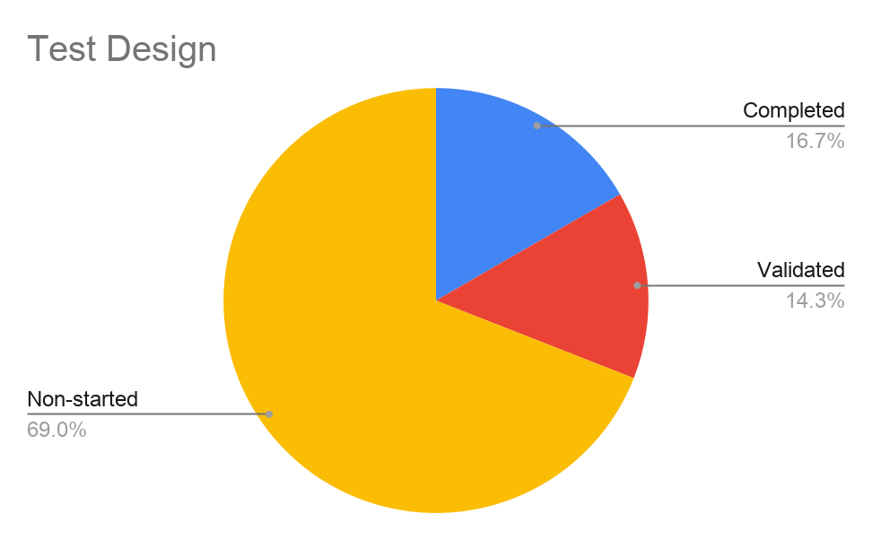

Figure 6. Pie Chart Test Cases Design

As observed no approval has taken place despite a minimal Test Case Creation.

Test Case Design | 22.04%

Directly depending from the previous section, no Corrections have taken place.

Testing | 3.78%
Corrections | 0.00%

Usability
  - Golden rules

The 8 Golden Rules of usability come from the renowned computer scientist Ben Shneiderman, first presented in his book Designing the User Interface: Strategies for Effective Human-Computer Interaction in 1986. These rules aim to create intuitive, functional, and consistent interfaces.

These are the rules:
- Strive for consistency
- Enable frequent shortcuts
- Offer informative feedback
- Design dialogs that yield closure
- Offer user control and freedom
- Keep users informed with a simple and natural design
- Prevent errors
- Provide help and documentation

Based on these principles, the view designs were developed with a strong focus on usability and consistency. The following design decisions were applied:

- Maintaining a consistent color palette, especially for accent colors, to reinforce visual identity and recognition
- Using uniform typography and spacing to improve readability and coherence across all views
- Ensuring consistent layout patterns so users can easily predict where to find information
- Providing clear and immediate feedback for user actions (such as buttons, forms, and navigation)
- Minimizing cognitive load through simple and intuitive interfaces
- Designing clear navigation flows that guide users naturally through tasks
- Preventing user errors by using constraints, validations, and helpful prompts
- Focusing on reducing the number of clicks, especially with the most important features to the system (Reports, Activity log personal/team, projects).

This can be seen in the home page, where consistent colors, typography, and layout make navigation predictable and easy to understand. Clear feedback, simple structure, and accessible shortcuts reduce cognitive load, while validations and intuitive interactions help prevent errors and guide users efficiently.

  - Usability tests
User interface tests were done with external users, however we gave more importance to the heuristic evaluation with our systems end users.

From the first draft of a functional prototype we obtained the following reported feedback:

- Report generation components would be better off with an additional form of choosing a specific range of dates rather than having to enter the specific dates. For example, for the team/project views choosing a daily/weekly/monthly/quarterly format would be best, especially a weekly one.
Before. Usability Iteration #1.
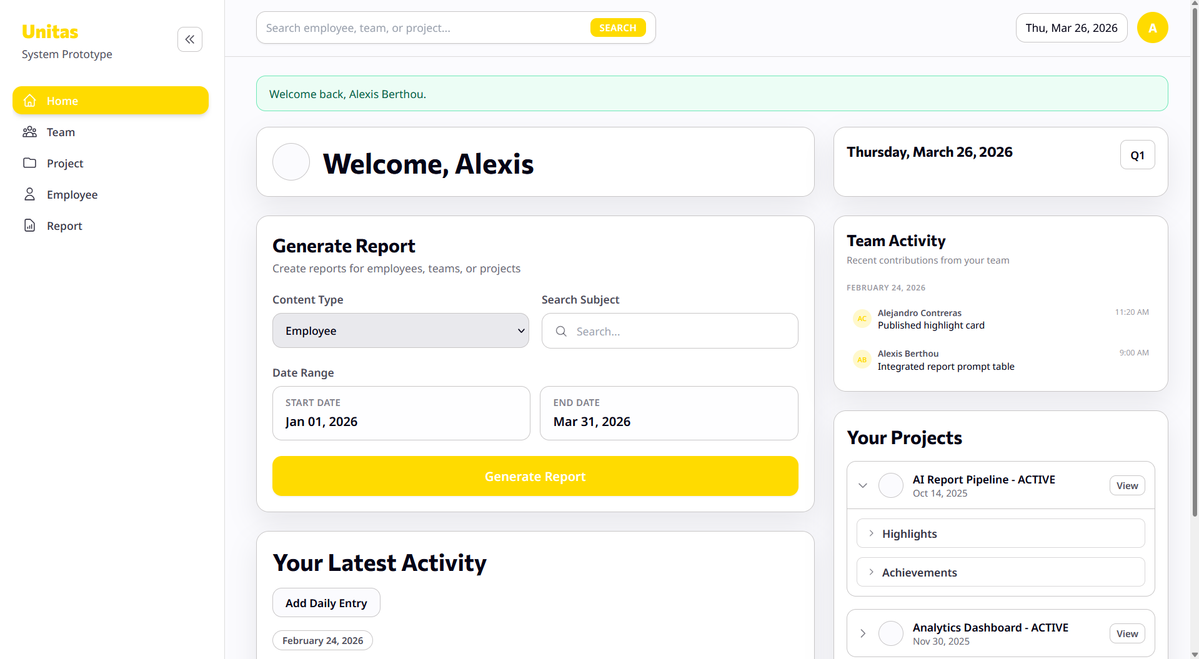

After Usability Iteration #1
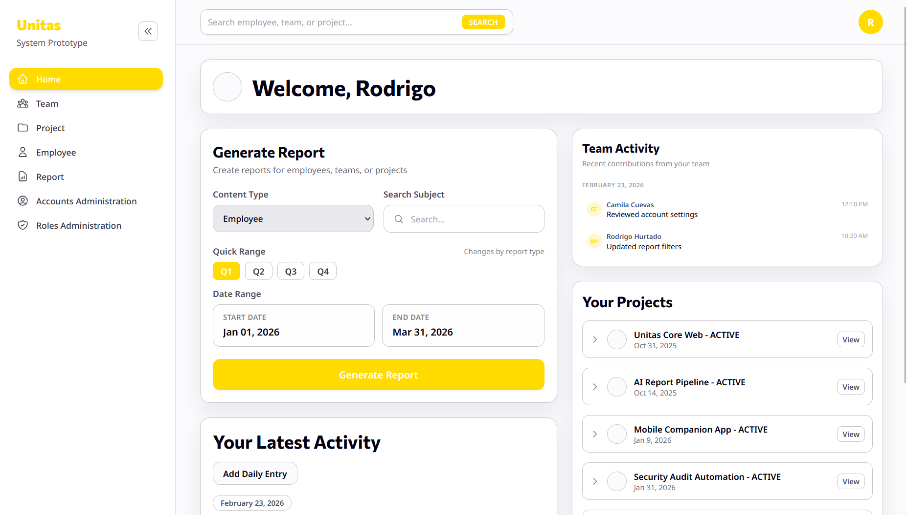
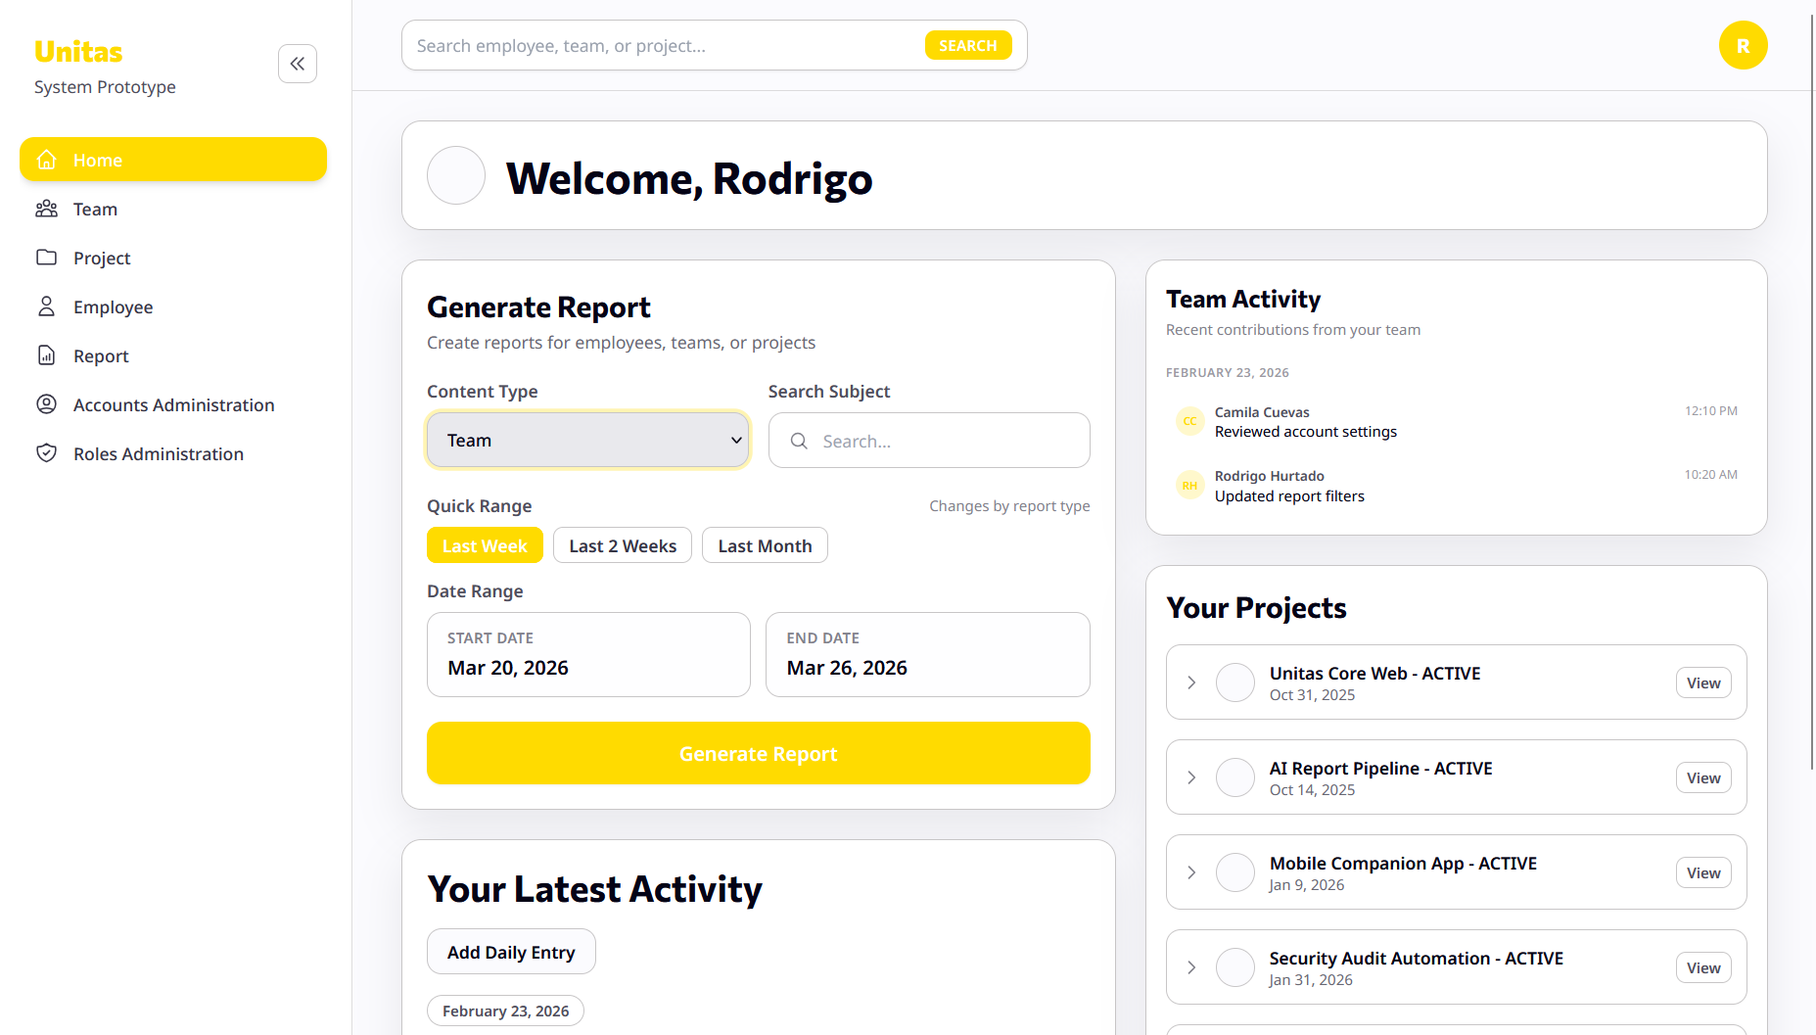

- Some components feel like they generate a lot of useless empty space and make it difficult to navigate such as the your Projects component which in addition to having a specific project selection has deployable components for highlights and achievements. However, it would be better to reduce clicks in order to see the information more easily.
Before Usability Iteration #2

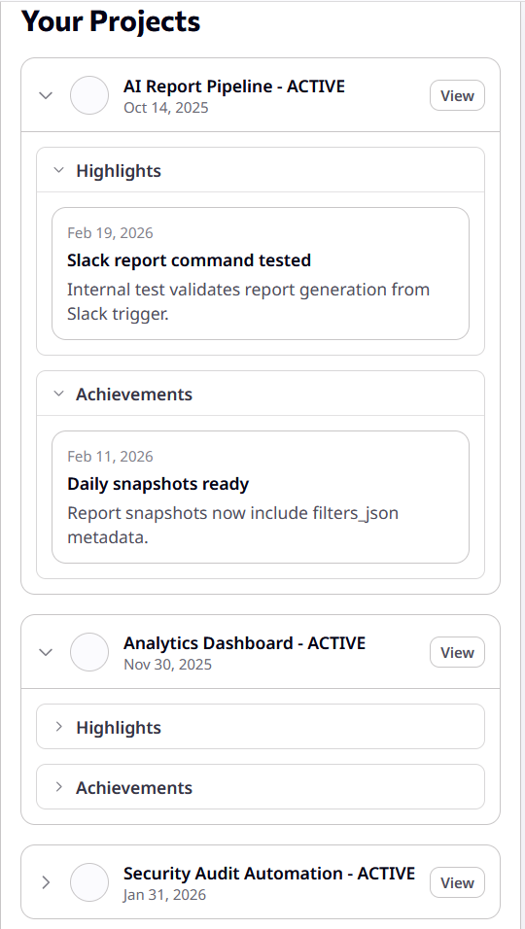
After. Usability Iteration #1
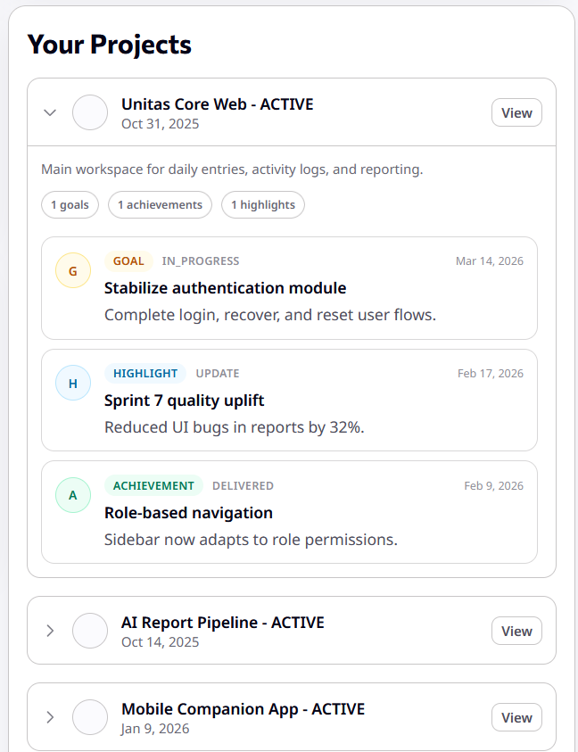

- Participant management is not intuitive and lacks some functionality, it would be better if people could add others to your project.

Before Usability Iteration #3
Modification of the presented view are not available for the current iteration.

After Usability Iteration #3

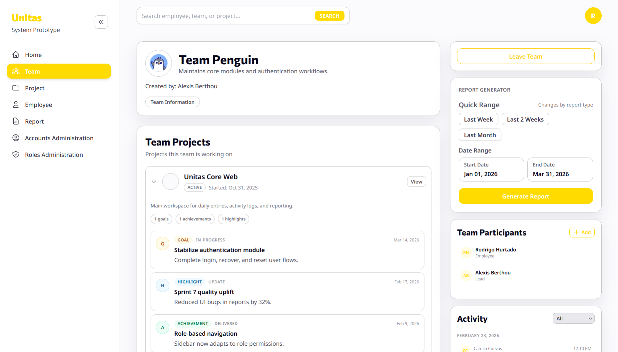

Reports
Until the current project point the theoretical creation of the required reports for the client has been concluded, resulting in three report models divided into three content types: Employee, Team and Project.

It is important to notice that the client specifically required no format needed, only content shown on the screen and a copy functionality. The main focus of the present section is the content of each and the way their information is obtained from the designed data model.

The three reports have two main sections: What went well and What could be improved. The reports will be delivered as a text ready to copy and paste by the users.

The report for an Employee looks like it follows:

What went well?

Project: Endorsements

- Implemented several UI improvements based on feedback from internal demos, embracing openness to team input to refine the user experience and address usability issues identified during reviews.
- Fixed bugs affecting task interactions and key user flows, taking responsibility for improving platform stability and ensuring smoother user interactions.
- Addressed pull request feedback and incorporated suggested changes through candid technical discussions that helped move features forward while maintaining code quality standards.
- Completed code reviews for teammates’ pull requests, helping maintain consistency with the project’s architecture and strengthening collaboration across the team.
- Updated preview functionality to improve reliability and better align it with the intended user workflow, contributing to the team’s ambition to continuously improve the product experience.

Project: Ready to Share

- Participated in technical discussions and reviews with openness to different perspectives in order to clarify implementation details and refine the feature design.
- Assisted in testing and reviewing updates to help ensure stable integration with existing platform features.
- Improved form validations and error handling to prevent incorrect inputs and provide clearer feedback to users, contributing to a more reliable experience.
- Refined confirmation messages and UI feedback states to make system responses clearer and more intuitive.
- Integrated shared components developed by another squad, helping build stronger cross-team connections while maintaining UI consistency across the platform.
- Contributed to work related to the Signed Petition Home MVP, which is showing promising early results: the view-to-share conversion rate is ~8% compared to ~4% in the control, representing a 100% increase [LINK].
- Helped support improvements tied to sharing flows, where 48% of shares in the Signed Petition Home are coming from header share channels and 51% from the checklist feature, including 36% from “text a friend” / “email a friend” and 15% from social sharing options [LINK].

What could be improved?

- Strengthen coordination when integrating changes across different areas of the system or across teams.
- Continue improving documentation of technical decisions to support knowledge sharing and team alignment.
- Plan cross-feature integrations earlier to reduce last-minute adjustments during development.

The report for a Team looks like it follows:

What went well?

Project: Endorsements

Camila Cuevas (@ana.cuevas)
- Implemented several UI improvements based on feedback from internal demos, refining the user experience and addressing usability issues identified during reviews.
- Addressed pull request feedback and incorporated suggested changes through technical discussions that helped maintain code quality standards [LINK].

Alexis Berthou (@alexis.berthou)
- Contributed to architectural alignment through code reviews and technical discussions, helping maintain consistency across modules.
- Supported feature development by reviewing and validating implementations against project standards [LINK].

Alejandro Contreras (@alejandro.contreras)
- Collaborated on resolving issues affecting core flows, contributing to improved system stability.
- Participated in pull request reviews and discussions to ensure quality and alignment with system design [LINK].

Rodrigo Hurtado (@rodrigo.hurtado)
- Strengthened collaboration through consistent participation in code reviews, helping enforce architectural consistency.
- Supported ongoing improvements by validating feature behavior and identifying edge cases during development.

Project: Ready to Share

Camila Cuevas (@ana.cuevas)
- Participated in technical discussions and reviews to clarify implementation details and refine feature design [LINK].
- Improved form validations and error handling, reducing incorrect inputs and improving user feedback.

Alexis Berthou (@alexis.berthou)
- Collaborated on integrating shared components from another squad, ensuring UI consistency across the platform.
- Supported cross-team alignment by coordinating integration efforts and validating shared functionality.

Alejandro Contreras (@alejandro.contreras)
- Assisted in testing and reviewing updates to ensure stable integration with existing platform features.
- Contributed to maintaining system reliability during feature rollouts.

Rodrigo Hurtado (@rodrigo.hurtado)
- Participated in testing and validation of feature updates, helping ensure smooth integration across modules.
- Supported coordination efforts between different parts of the system during development.

Team Impact (Cross-functional contributions)
- Contributed to the Signed Petition Home MVP, achieving a ~8% view-to-share conversion rate vs ~4% in the control, representing a 100% increase [LINK].
- Enabled diversified sharing behavior, where 48% of shares come from header channels and 51% from the checklist feature, including 36% via direct messaging (text/email) and 15% via social sharing options [LINK].

What could be improved?
- Improve coordination across team members when integrating changes in different areas of the system.
- Strengthen documentation of technical decisions to support shared understanding and onboarding.
- Plan cross-feature integrations earlier to reduce last-minute adjustments and improve delivery predictability.

Finally, the report for a Project looks like it follows:

What went well?

Camila Cuevas (@ana.cuevas)
- Implemented UI improvements based on feedback from internal demos, refining the user experience and addressing usability issues identified during reviews.
- Fixed bugs affecting key user flows, improving platform stability and ensuring smoother user interactions.
- Improved form validations and error handling, reducing incorrect inputs and enhancing user feedback.
- Refined confirmation messages and UI feedback states, making system responses more intuitive.
- Participated in technical discussions and reviews to clarify implementation details and refine feature design [LINK].

Alexis Berthou (@alexis.berthou)
- Contributed to architectural consistency through code reviews and technical discussions, ensuring alignment across different modules.
- Supported integration of shared components, maintaining UI consistency across the platform.
- Collaborated in cross-team efforts to validate implementations and ensure alignment with shared standards [LINK].

Alejandro Contreras (@alejandro.contreras)
- Assisted in testing and reviewing updates, ensuring stable integration with existing platform features.
- Contributed to resolving issues affecting core functionality, supporting overall system reliability.
- Participated in pull request reviews and validation processes to maintain quality standards [LINK].

Rodrigo Hurtado (@rodrigo.hurtado)
- Strengthened collaboration through consistent participation in code reviews, helping enforce architectural consistency.
- Supported validation of feature behavior and identification of edge cases during development.
- Contributed to coordination efforts across different parts of the system during feature integration.

Overall Impact
- Contributed to the Signed Petition Home MVP, achieving a ~8% view-to-share conversion rate vs ~4% in the control, representing a 100% increase [LINK].

What could be improved?

- Improve coordination across team members when integrating changes in different areas of the system.
- Strengthen documentation of technical decisions to support shared understanding and alignment.
- Plan cross-feature integrations earlier to reduce last-minute adjustments and improve delivery predictability.

Production Environment Identification
  - Production Environment Identification
For the deployment of the Unitas System web application, the selected production environment—assigned by our educational partner, Eng. Bernardo Laign—is an Ubuntu Server.

An Ubuntu Server is a remote machine running a Linux-based operating system, specifically the Ubuntu distribution. This distribution is widely adopted in server environments due to its stability, security, and long-term support. The server is responsible for hosting and continuously running the web application once it has been properly configured, ensuring availability to end users over the internet.

  - Environment Justification
The choice of an Ubuntu Server over alternative solutions (such as managed cloud platforms like Vercel or Heroku) was made to prioritize educational value and technical understanding. By performing a manual deployment, the development team gains direct exposure to the underlying infrastructure, configuration processes, and runtime behavior of a web application in a production environment.

This approach allows for a deeper comprehension of key concepts such as server configuration, process management, reverse proxy behavior, and secure communication protocols, which are often abstracted away by modern automated platforms.

  - Environment Separation
It is important to distinguish between the development and production environments:

Development Environment:
Local machines where the application is built and tested. Configurations are flexible, and debugging tools are enabled.
Production Environment:
The Ubuntu server where the application is deployed for real users. This environment prioritizes stability, security, and performance, and uses environment-specific configurations (e.g., .env variables, optimized settings, restricted access).

This separation ensures that changes in development do not directly impact the live system.

  - Deployment Process
The deployment process follows a manual configuration approach, designed to reinforce understanding of each component involved. The steps are as follows:

- Establish connection with the server
Access the remote Ubuntu server via SSH to begin the configuration process.
- Install dependencies
Install required software components, including:
- Node.js (runtime environment)
- Express (application framework)
- MariaDB/MySQL (database management system)
- Nginx (web server and reverse proxy)
- Clone the project repository
Retrieve the application source code from GitHub using the repository URL.
- Configure environment variables
Manually create and load the .env file, which stores sensitive configuration data such as API keys, database credentials, and session secrets. This prevents exposure of confidential information in the source code.
- Run the application
Start the Node.js application to verify correct installation and functionality.
- Configure and initialize PM2 (Process Manager)
PM2 is used to manage the application process in production. Its responsibilities include:
- Automatically restarting the application in case of failure
- Running the application in the background
- Ensuring the application starts on server reboot
- Providing logging and monitoring capabilities
- Configure Nginx as a reverse proxy
Nginx acts as an intermediary between client requests and the Node.js application. Its functions include:
- Listening on ports 80 (HTTP) and 443 (HTTPS)
- Forwarding incoming requests to the application running on a local port (e.g., 3000)
- Handling HTTPS encryption
- Serving static files efficiently
This setup prevents direct exposure of the application and improves performance and security.
- Domain and HTTPS configuration
The domain name is configured to point to the server’s IP address via DNS. Additionally, an SSL/TLS certificate is installed using Let’s Encrypt to enable secure HTTPS communication.
Runtime Architecture Overview

  - Security Considerations
Several measures are implemented to improve the security of the production environment:

Environment variables are used to store sensitive data securely
- HTTPS encryption is enabled via Let’s Encrypt certificates
- Nginx reverse proxy prevents direct access to the application server
- Database access is restricted to the local server (not publicly exposed)

These practices help reduce vulnerabilities and protect user data.

  - Update and Maintenance Process
When modifications are made to the application, the update process consists of:

- Pulling the latest changes from the GitHub repository
- Installing any new dependencies if required
- Restarting the application using PM2

PM2 ensures that the restart process is controlled and that the application resumes operation quickly. It is important to note that restarts must be triggered manually or through scripts, as automatic reload on code changes is not typically enabled in production environments.

  - Limitations and Future Improvements
Current Limitations
- The deployment process is manual, which may be prone to human error
- No CI/CD pipeline is implemented for automated deployment
- The system runs on a single server, limiting scalability and fault tolerance
- Future Improvements
- Implementation of a CI/CD pipeline (e.g., GitHub Actions) for automated deployments
- Use of containerization technologies such as Docker for consistent environments

  - Final Considerations
The decision to perform a manual deployment is intentionally aligned with the educational objectives of the project. By avoiding fully automated platforms, the team gains a comprehensive understanding of the technologies and processes involved in real-world web application deployment, forming a strong foundation for future advancements and more complex infrastructures.

Updated Work Plan
  - Pending Activities
Due to team decisions and agreed terms, the presented Advancement No. 4 “Concept Tryal” misses the following terms:

- Arrive to a solid 30% in Test Case Design, Testing and Correcting of the developed Functional Requirements.
- Usability: Present a greater pool of opinions and modifications to be realized.

  - Work Plan Failures
During the current working period (which covers the space between the Progress No. 3 [March 6th, 2026] - No. 4 [March 27th, 2026]) , decisions taken by the team led to an incomplete and hurried development during the last week. These decisions are presented below in order to identify them and avoid their repetition to all costs:
- During Advancement No. 3 present the AI generated prototype as navigational prototype and avoid the generation of the views until the last moment.
- Lack of Communication to share finished responsibilities and redistribution of them.
- Take the TEC Week too freely due to individual responsibilities or decisions.
- Late development started delegated until (March 23rd, 2026).
- Discrepancies between frontend and backend development.
Additionally, the acquired learning section (below) will include some of the actions to be taken to avoid the mentioned problems.

  - Future Workload
Taking the expected terms of the Progress Report No. 5 as a guide for the design of the workplan together with the acquired team knowledge and pending activities, the following plan is proposed:

Time window: March 28th - April 17th

- Completed Functional Requirements Analysis.
- 60% of Design, Development, Testing and Corrected Functional Requirements. Main focus.
- 60% Test Case Design, proof of usage and corrections originated from them.
- 30% of Educational Partner–Eng.Bernardo Laign– Approved Functional Requirements.
- Execution Architecture Description. UML Deployment Diagram design that clearly presents the production environment.
- Workplan & Acquired Learning.

Goal (No. of the previous terms for Progress Report No. 5) | Description | Responsible | Date-Range
2 | Sequence Diagram Revision | Rodrigo & Alexis | March 28th-30th
3 | Test Case Design | Alejandro | March 28th-April 3rd
3 | Test Case Validation | Alejandro & Camila | April 2nd-5th
4 | Meetings with Eng. Bernardo Laing | Rodrigo & Alexis (All members can participate) | April 1st,8th,10th,15th
5 | UML Deployment Diagram Design | Camila | April 10th-13th
6 | Acquired Learning & Workplan Meetings | All members. Lead by Rodrigo | March 30th-April 1st, April 6th-10th, April 13th-17th
2 | Enrichment of Database | Rodrigo | March 28th-29th
2 | Development | All members. Coordinated through daily meetings. | March 28th - April 17th
2 | REP-01-Backend & API connection | Rodrigo | March 30th-April 1st
2 | Project Module | Camila | March 30th-April 1st
2 | AL-01 Backend & API connection | Alexis | March 30th-April 1st
2 | Account Module | Alejandro & Alexis | April 4th -8th
2 | Team Module | Alexis & Rodrigo | April 4th -8th
2 | Employee Module | Alexis & Rodrigo | April 4th -8th
2 | Admin Role Module | Camila | April 4th -8th
2 | Admin Account Module | Alexis | April 9th -April 13th
2 | Search module | Rodrigo | April 9th -April 13th
2 | Testing | Alejandro | April 4th - April 13th
2 | Refinement | All members | April 14th-April 17th

  - Previous Workload
The activities done during the current Advancement Report (No. 4) correspond to the following plan:

Time window: March 9th - March 27th
Estimated time: 96 h
- 90% of the Functional Requirements Analysis
- System Architecture description.
- 30% of Design, Development, Testing and Corrected Functional Requirements.
- 30% Test Case Design, proof of usage and corrections originated from them.
- Usability demonstration.
- Report design and integration within the prototype.
- Production environment identification.
- Workplan & Acquired Learning.

The team developed an early Functional Requirement Analysis and System Architecture design, which consisted of discussion of the requirements and design of activity diagrams and sequence diagrams. The team also developed an early system design and had a clear vision of the production environment and usability because of our communication with the Educational Partner. However, the previously mentioned TEC Week that the team didn’t use to develop resulted in an accumulation of hours in the last week. Thus, the real time window for development, test case design and testing was from March 23rd to March 27th, causing an accumulation of hours and thus, in pressured work.

Acquired Learning
For the Limbo Software Development team the present progress represented a great challenge in a rush to accomplish most of the suggested requirements for evaluation. It was clear that we would not be able to receive a complete grade as complete sections were missing and we started development too late; however, this is also the progress we have learned most from.

Not only by the content review in class related to SQL, AJAX, file loading, overall connections between the web application logic, but by getting the great reality shock that subjects in university are no longer another subject, but the mere foundation of the principles we will apply to the engineering we perform outside of the institution.

Looking towards the good of the project instead of our own good by getting a grade has been a new challenge more than any functional requirement or diagram definition.

From the present report we recognize our decisions took us here, but it's better having faced this reality this early, rather than having a perfect submission not looking for our project or our knowledge but rather for a number in a paper.

We will work carefully, thoughtfully in a clear and clean structure that focuses on the code logic and legibility, the definition and follow of our standards, a minimum integration of AI agents into backend and overall giving our client a product which whole engineering was planned, designed, developed and tested by the developer team. We look forward to the next challenge that makes us fall and keep improving with more organization, order and motivation.

References
How to manage process in Linux. (2020, mayo 11). GeeksforGeeks.
https://www.geeksforgeeks.org/linux-unix/process-management-in-linux/

Walia, A. S. (2025, diciembre 19). Set up and configure an application server on Ubuntu 24.04.
Digitalocean.com; DigitalOcean. https://www.digitalocean.com/community/tutorials/set-up-configure-application-server-ubuntu-24-04

(S/f). Stackexchange.com. Recuperado el 27 de marzo de 2026, de
https://unix.stackexchange.com/questions/537814/web-server-in-ubuntu

